How to Insert/Change the Two CR2032 Batteries
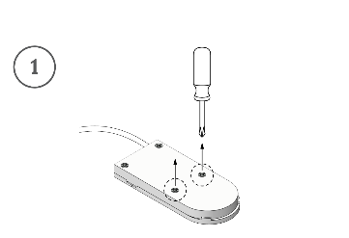
Step 1
Unscrew the two (2) screws nearest the curved edge of the battery compartment (Screwdriver not included)
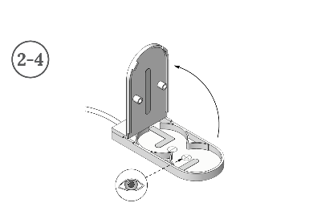
Step 2
Open the battery compartment
Step 3
If applicable, remove the used batteries and dispose of them correctly (see below)
Step 4
Examine the inside of the battery compartment and locate the plus (+) and negative (-) symbols
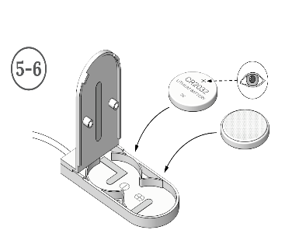
Step 5
Locate the plus (+) symbol on the new battery
Step 6
Insert the new batteries, matching the plus (+) and negative (-) side of the batteries with the symbols in the battery compartment
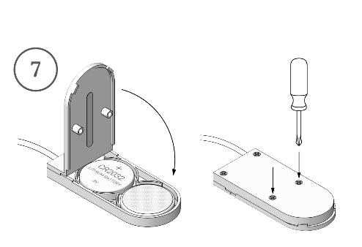
Step 7
Close the battery compartment and screw the screws back in place. Make sure the compartment is securely closed

Battery

